TOPOLOGY

# PROCEDURE:

*open the cisco packet tracer desktop and select the devices given

*take a switch and link to the end devices

*link every device with the switch

*provide the ip address to each device

*transfer message from one device to another device and check the table for

Validation

# BUS TOPOLOGY:

All devices share single communication line or cable

-use csma or one host as master/slave

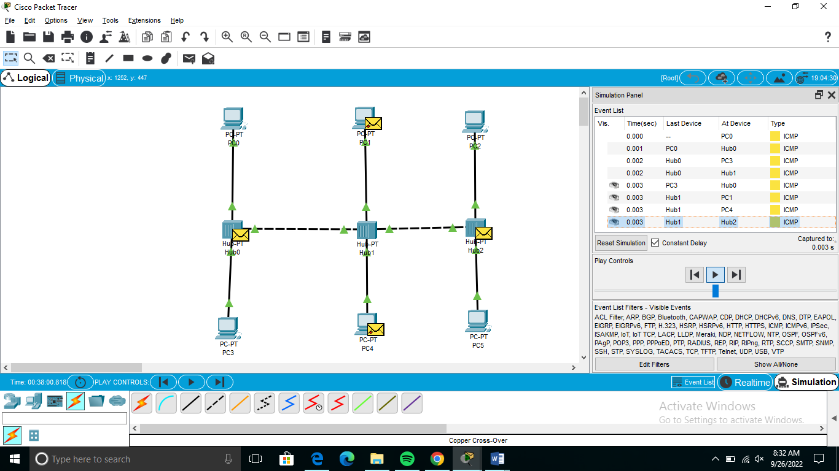

# RING TOPOLOGY:

It forms a ring connecting devices with exactly two neighbouring devices

-transmission is uni directional

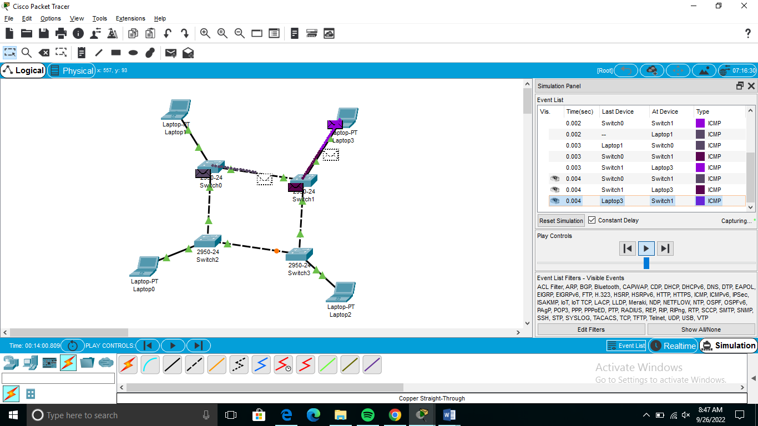

# HYBRID TOPOLOGY:

It contains a combination of all different types of networks

-example:internet

